**CHAPTER-1**

**INTRODUCTION**

* 1. **OVERVIEW**

With the rapid development of economy, chemical industrial park construction and production activity are increasingly frequent, leading to increasing probability of environmental pollution accidents, especially air pollution accident. Affected by meteorological and geographical conditions, air pollution will be highly clustered in a short time after happening, causing great harm or even extreme destruction to both human and environment. So it is particularly important to set up a real-time air pollution monitoring system.

Using laboratory analysis, conventional air automatic monitoring system has relatively complex equipment technology, large bulk, unstable operation and high cost. High cost and large bulk make it impossible for large-scale installation. This system can only be installed in key monitoring locations of some key enterprises, thus system data is unavailable to predict overall pollution situation. To overcome defects of traditional monitoring system and detection methods and reduce test cost, this paper proposes a method combining IOT technology with environment monitoring. By replacing monitoring equipment in traditional empirical analysis with sensor network in IOT technology, through which inexpensive sensors can be laid out flexibly in the whole area to monitor Omni-directionally to provide data support for prediction.

Environmental pollution has gradually emerged and now becomes a big problem, especially in well-developed big cities. With the improvement of living standard, people pay more and more attention to the physical health. Air pollution monitoring and improvement is becoming an urgent request. The decline in quality of the environment affects the quality of human life and healthiness. Serious pollution incidents not only cause healthiness problems, but also create more and more social problems.

The development of information technology has experienced three time periods. The first is the computer interconnection based internet era; the second is the information interconnection based network information era, and the third is the present internet of things era. Right now IOT technology is widely used in monitoring system, healthcare system, etc. Some of them have achieved accurate air quality measurement results by using monitoring systems. Through analyzing air quality data, results can further impact the economy, and promote green economic development.

The current researches and development of similar systems are mainly divided into two categories: The first category is interactive systems. Using this category of systems, we can easily set and query pollutant information, and further manage and change related pollutant information. The second category is real-time systems .This category of system is the mainstream to implement air quality monitoring systems. However implementation methods are very different. The biggest difference is the wireless transmission mode.

**1.2. LITERATURE SURVEY**

1. **Chen Xiaojun1, Liu Xianpeng2, Xu Peng3: IOT- Based Air Pollution Monitoring and Forecasting System, International Conference on Computer and Computational Sciences (ICCCS) 2015**

Perception layer mainly includes Field Sensor Network which based on front-end acquisition device. The slather of sensors reduces the cost of hardware. Perception layer is realized mainly by establishing a stable and reliable monitoring network system, including monitoring sites selection, environment sensor deployment and meteorological sensor deployment, etc.

In environmental sensor deployment, all kinds of environmental sensors are installed in monitoring points, including sulfur dioxide, nitrogen dioxide, smog, inhalable particle, carbon monoxide, chlorine, hydrogen chloride and hydrogen fluoride sensors.

The primary function of network layer to transmit environmental and meteorological data, connect all the air sensors and meteorological sensors deployed in monitoring area to a central server and transmit the data perceived by sensors to data center in real time.

The whole application layer system is mainly to process and analyze air pollutant data, evaluate air quality and then predict the trend air quality develops over a period of time in the future. From a functional point of view, the whole application layer includes air quality evaluation and air pollution forecast. Due to complex relationship between air quality, air pollutants trend and meteorological factors, it is difficult to mine the useful information in historical data to predict accurately with traditional prediction method.

Air quality prediction is to predict future trend of air quality based on current situation, pollutant dispersion, current weather conditions and geographical position of monitoring area, so as to provide decision support for emergency disposal and rescue after pollution accident happens.

Air pollution monitoring and forecasting system designed in this paper proposed a good solution to the complexity of air pollution. The use of a large number of sensors ensures monitoring accuracy, reduces monitoring cost and makes monitoring data in monitoring area more systematic and perfect. A large number of field data provided by front-end sensor network makes big data analysis in background application layer more direct and effective, providing a real and effective decision-making basis for emergency response after pollution accident happens.

1. **ShwetalRaipure. Deepak Mehetre: Wireless Sensor Network Based PollutionMonitoring System in Metropolitan Cities, IEEE ICCSP conference,2015.**

We use various sensors to measure the percentage of pollutants present in the particular areas of the city. Using sensors we can also detect temperature and humidity present in the air. By using Bluetooth controller the collected data will send to server. Then we apply ID3 data mining algorithm which is useful for calculation of the percentage of pollutants in the air as well as temperature and humidity. With the help of data mining algorithm, we will give future predictions to the particular area in the city and can also provide alarm to highly polluted area 1836.

Develop architecture to define nodes and their interaction. Collect air pollution readings from different region of interest. Collaboration among thousands of nodes to collect readings and transmit them to a gateway, which minimizes duplicates and invalid values. Use of appropriate data aggregation to reduce the power consumption during transmission of large amount of data between the thousands of nodes. Visualization of collected data from the WSN using statistical methods such as tables and line graphs. Provision of an index to categorize the various levels of air pollution, which represent the seriousness of air pollution. Generation of reports as well as real-time notifications during serious states of air pollution for use by appropriate authorities.

ID3 is basically the decision tree algorithm. So to create the decision tree we first need to create the root node. ID3 algorithm works on sensor datasets. ID3 algorithm will also work on missing attributes. Decision tree can use for providing alert to polluted area. We are considering parameters MQ5, MQ7, temperature and humidity dataset. According to dataset ID3 algorithm it calculates Entropy and information gain using formula.

According to information gain if certain area is highly polluted then our system will provide alert messages and based on the datasets we can also predicts the future pollution.

1. **Siva Shankar Chandrasekaran, Sudharshan Muthukumar and Sabeshkumar Rajendran: Automated Control System for Air Pollution Detection in Vehicles,** **4th International Conference on Intelligent Systems, Modelling and Simulation,2013**

Over the years, there have been several regulations made by the Government to control the emission from vehicles; most of them being unsuccessful at the same.

The standards and the timeline for implementation are set by the Central Pollution Control Board under the Ministry of environment and forests. Bharat stage emission standards are emission standards instituted by the Government of India to regulate the output of air pollutants from internal combustion engine equipment, including motor vehicles. The first emission norms were introduced in India in 1991 for petrol and 1992 for diesel vehicles. These were followed by making the Catalytic converter mandatory for petrol vehicles and the introduction of unleaded petrol in the market.

On April 29, 1999 the Supreme Court of India ruled that all vehicles in India have to meet Euro I or India 2000 norms by June 1, 1999 and Euro II will be mandatory in the NCR by April 2000. Car makers were not prepared for this transition and in a subsequent judgment the implementation date for Euro II was not enforced. The standards, based on European regulations were first introduced in 2000. Progressively stringent norms have been rolled out since then. All new vehicles manufactured after the implementation of the norms have to be compliant with the regulations. Since October 2010, Bharat stage III norms have been enforced across the country. In 13 major cities, Bharat stage IV emission norms are in place since April 2010.

The phasing out of 2 stroke engine for two wheelers, the stoppage of production of various old model cars & introduction of electronic controls have been due to the regulations related to vehicular emissions. The sensing of the emitted gases are done using various sensors and devices. The past decade, has seen several research activities that have been taking place to develop semiconductor gas sensors. In the paper, the quality of air in the car cabin was analyzed using semiconductor (MOS) gas sensors. The semiconductor sensors have been used to detect the pollutant level of the vehicles. This paper concentrates mainly on three blocks; smoke detector, microcontroller and fuel injector. The smoke detector detects the pollutants (CO, NOx, etc.) continuously. The microcontroller compares the level of pollutants with the stipulated level allowed by the government. When the pollutant level exceeds the standardized limit, it sends a signal to the fuel injector. Onreceiving a signal from the controller, the fuel injector stops the fuel supply to the engine after a particular period of time.

1. **Souhir BEDOUI, Sami GOMRI and Hekmet SAMET:** **Air Pollution Monitoring System using LabVIEW, 12th International Multi-Conference on Systems, Signals & Devices, 2015**

A Wireless Sensor Network (WSN) is a collection of very small devices, named sensor nodes, variants of a few dozen to several thousand elements. In these networks, each node is able to monitor their environment and respond when needed by sending the collected information to one or more collection points, using a wireless connection. The sensor node architecture consists of four major parts, the acquisition unit, the processing unit, the communication module, battery.

The sensor network consists of three sensors. The Gas sensor GS05 operates as a gas sensitive resistor specified for measuring concentrations of H2S. The principal characteristics of GS05 are fast response (less than 1minute), long service life (in excess of 10 years) and a variable operating temperature between -20 °C and + 60 °C. Standard characterization is three gas points of 25, 50 and 100ppm .The temperature sensor LM35 is an integrated circuit sensor that can be used to measure temperature with an electrical output proportional to the temperature. It is characterized by low power consumption (about 60 μA), very low power dissipation and excellent linearity over the entire sensitivity range. The LM35 is rated to operate over a −55°C to +150°C temperature range .Humidity Sensor HIH-4000 is designed for low power consumption of about 200 μA. It is characterized by its linear voltage output With typical current draw of only settling time 70 ms & operating humidity 0 to 100% at -40 to 80 degree Celsius operating temperature .PIC16F876 microcontroller has been chosen for this application. It is a 28 pin, 8-bit microcontroller. It requires 5V supply .For the simulation of our system LabVIEW environment has been used. LabVIEW is a graphical programming language and hence all programming is made with blocks representing functions, icons representing variables (called ‘‘Controls” or ‘‘Indicators” which are depicted in the front panel) and lines representing variables being passed between different functions.

1. **Suganya E, Vijayashaarathi S:** **Smart Vehicle Monitoring System for Air Pollution Detection using Wsn,** **International Conference on Communication and Signal Processing, 2016.**

WSNs consist of small self-sufficient nodes that have the benefits of mortal small, efficient moderately low in price. Wireless Sensor Networks have main application of real-time Monitoring. Currently, the growth on sensing, processing and communication technologies have compact the charge of sensors, made them smaller in range and power efficient. Would prefer to power efficient. It is implemented in many applications such as agriculture, health monitoring, environment and mobile communication.

The air contaminants include smokes, gases, dust, paper hashes, poisonous chemical products and many polluted materials as LTE-M system model. The architecture for real time monitoring of indoor chemical polluted materials such as NO2, Humidity, Carbon monoxide sensor. These chemical materials highly toxic and cause respiratory problems .The gas sensors were placed to the travelling vehicles without using wired or infrastructure network. Information exchange between the source and destination will be more efficient, fast and secure by using Wi-Fi and GPRS. The gas sensor was placed to the travelling vehicles in the indoor and outdoor around the cities. These sensor devices are capable of sensing, processing and transmitting how much of gas levels polluted in this vehicles data is collected through server nodes and mobile nodes. Monitoring of vehicles in both urban and rural areas is possible by using internet/intranet. The humidity sensor is measured to the air moisturized level, temperature sensor is measured to be heat produce in the vehicles, NO2 sensor is measured to emissions spark-ignition gasoline engines activities and finally CO sensor is measured to the how much of carbon pale gas emits in the vehicles. The gas levels information will be transmitted to the computer by using radio transmission device. Every node in a sensor network is laden with a radio transceiver or various other wireless communication device, a small microcontroller, and an energy source most frequently cells/battery. The nodes of sensor network have mutual capabilities, which are frequently deployed in a random mode. These sensor nodes essentially consist of three parts: sensing, processing, and communicating.

The proposed method achieves the monitoring of humidity, temperature, CO, NO2 levels of the travelling vehicles by using humidity sensor, temperature sensor, CO sensor, NO2 sensor. Travelling vehicles can be monitored by using large number of sensing parameters (coverage of vehicles, area size and number of vehicles, speed of the transmission data) computing to achieve the better analysis of travelling vehicles. These measured gas values can be store the details of vehicles and the android application can be created to provide alert message to the smart phones. By using cloud network large amount of data of different vehicles records can be stored and retrieved for future purpose. Hence analyzed data can be viewed anywhere in the world can access the information about pollution levels through the cloud network.

1. **Yangyang Ma, Shengqi Yang, Zhangqin Huang, Yibin Hou, Leqiang Cui, and Dongfang Yang: Hierarchical Air Quality Monitoring System Design, International Symposium on Integrated Circuits (ISIC), 2014**

The whole system consists of two major parts. The first part is the front-end IOT-based monitoring hardware system, and the second part is the back-end software service system which processes the air quality thing data. The front-end monitoring system is divided into hierarchical monitoring sections and sub-regional monitoring sections. Front-end monitoring platform uses WSN technology as its core technology, and transmits information via ZigBee protocol. Background service system uses JSP and MySQL languages for thing data processing. At last, JSP pages get real-time air quality information by accessing the database and display it dynamically on the web front page.

The MQ135 sensor to monitor air quality condition. When polluted air goes through the sensors, its conductivity increases with the increase of gas concentration in the polluted air. By implementing a simple circuit, it can convert the change in conductivity caused by the gas concentration change to the output signal amplitude. Further, MQ135 is very sensitive to ammonia, sulfur, benzene vapor, smoke and other harmful gas and is an ideal choice for air quality monitoring terminal node. Besides it is also a low-cost sensor which can be used for a variety of applications which need a large number of this kind of sensors for big coverage with low cost. In the front-end system, PM2.5 sensors are also used as a part of the air quality monitoring system end sensor nodes. Polluted air passes through the PM2.5 sensor in a given unit of time, the sensor finishes the calculation of Luo Pulse Time (LPO time) to measure the level of particulate matter in the polluted air. PM2.5 sensor is a great choice for providing reliable data on measuring the air dust level. For accuracy, this sensor can detect the dust particles which are as less as 1 micron in diameter. The sensor has two output modes, which can generate different sensitivity requirements with 5V DC power supply.

**1.3. OBJECTIVE**

The main objective of this project is to develop an application which is the combination of software and hardware that is used for sensing, processing and alerting the environment about the toxicity levels present in the air. This system will determine status and trends of ambient air quality and make normal people aware about the total pollutants and its sources. The information about the toxicity level of each pollutant is detected individually in PPM. The main aim of this project is to alert the environmentalists about the rising dangers of air pollution.

**CHAPTER 2**

**SYSTEM ANALYSIS**

**2.1 EXISTING SYSTEM**

Conventional air automatic monitoring system has high precision, but large bulk, high cost, and single datum class make it impossible for large-scale installation. Many air pollution detection and monitoring techniques have been employed to analyze air pollution but the system can only be installed in key monitoring locations of some key enterprises, thus system data is unavailable to predict overall pollution situation.

The IOT based system can detect the pollution level in a particular area and predicts the outcome using algorithms. Sensors combination also monitors pollution and detects the presence or absence of it. It uses NFC devices to gather and transfer data. Air pollution detection and monitoring model which detects pollution in air on the basis of data mining algorithm. The sensor grid is used to detect the sensor values from different gas sensors. Microcontroller is used to transfer the values from ADC to server. Data mining is used to calculate the pollutants from different areas. ID3 algorithm is used to calculate the values base on probability. Wireless sensors are also used to calculate the percentage of harmful gases present in the air .This system calculates the pollutants present in the air but we cannot forecast to avoid future pollution. Bluetooth module is used to connect the controller with client and the client connects with the server via web services.

Though the IOT based systems detects the pollution level , it has no integrated environment showing the levels of pollutants and also the systems which uses a Bluetooth support devices to gather data from the sensors are probably short range devices.

* + 1. **Drawbacks**

The drawbacks of the system are:

1. Measures the amount of toxicity but does not provide the source of pollutants causing the pollution
2. Surveillance of the area for air pollution but costly mechanism comparatively
3. It does not provide proper means for public to access the data and also lacks interface with the sensors and front end

**2.2 PROBLEM DEFINITION**

Air pollution is one of the environmental issues that cannot be ignored. increase in pollution in recent years are manifold. The people are unaware about the growing impact of pollution and increase in several pollutants level in the air. There is a lack of proper monitoring system in localities where pollution is increasing and the traditional air pollution and detection monitoring methods are typically expensive.Therefore we require a cheap integrated system to alert people of the increasing toxic level in air.

**2.3 PROPOSED SYSTEM**

Introducing PAVAN which is the combination of software and hardware that is used for sensing, processing and alerting the environment about the toxicity levels present in the air.It is an application to make normal people aware about the total pollutants and its sources. It aims to develop an application that can monitor certain atmospheric components and transfer the data continuously for the display. To determine status and trends of ambient air quality.It detects the toxicity level of each pollutants individually in PPM and alert the environmentalists about the rising dangers of air pollution using GSM/GPRS module**.**

Wireless sensor networks (WSN) facilitate monitoring and controlling of physical environments from remote locations with better accuracy. They have applications in a variety of fields such as environmental monitoring, indoor climate control, fire and flood detection, medical diagnostics, biocomplexity mapping and precision agriculture .The concentration of air pollutants such as CO2, CO, SO2, H2S, etc. is highly location-dependent. The urban areas with heavy traffic concentration and industrial areas have a considerable impact on the local air pollution. Since the air pollution monitoring stations are costly and so are limited in number, it is more convenient to replace these stations by a small and portable measurement system which includes various gas sensors and microcontroller. The use of WSN can make air pollution monitoring less complex and more instantaneous readings can be obtained. Moreover, accurate data with indexing capabilities will be able to obtain by using WSN.

A Wireless Sensor Network (WSN) is a collection of very small devices, named sensor nodes, variants of a few dozen to several thousand elements. In these networks, each node is able to monitor their environment and respond when needed by sending the collected information to one or more collection points, using a wireless connection. The major modules of the project include detecting the toxic level using sensors and processing the toxicity level. The sources of the pollutant are correlated and the pollutant data is stored in the web server.

**2.3.1 Advantages**

The advantages of the system are:

1. System is real time and the sensors have long life time.
2. The installation cost of the system is comparitively less compared to the other systems.
3. It is simple, compact and easy to handle.
4. The application is interactive, user friendly and provides a visual output.
5. Accurate measure of the toxicity level of each pollutants is detected individually in PPM.
6. The data is stored in the database in order to extract information for future use.

**2.4. FEASIBILITY STUDY**

Feasibility studies aim to objectively and rationally uncover the strengths and weaknesses of the existing business or proposed venture, opportunities and threats as presented by the environment, the resources required to carry through, and ultimately the prospects for success. In its simplest term, the two criteria to judge feasibility are cost required and value to be attained. As such, a well-designed feasibility study should provide a historical background of the business or project, description of the product or service, accounting statements, details of the operations and management, marketing research and policies, financial data, legal requirements and tax obligations. Generally, feasibility studies precede technical development and project implementation.

**2.4.1 Economic Feasibility**

Economic feasibility is the most frequently used method for evaluating the effectiveness of a new system. More commonly known as cost/benefit analysis, the procedure is to determine the benefits and savings that are expected from a candidate system and compare them with costs. If benefits outweigh costs, then the decision is made to design and implement the system. An entrepreneur must accurately weigh the cost versus benefits before taking an action. The proposed Air pollution monitoring and alert system is economically feasible to construct. This includes the initial investment of Arduino UNO, sensors and other components. Minimum requirements of the software specifications are less due to the open source tools.

By analyzing the parameters such as Software/hardware cost, Total estimated cost of the project, Financing of the project by equal sharing between our team members, Cost-benefit analysis. Projected cash flow and profitability, we conclude that our project is economically feasible.

**2.4.2 Technical Feasibility**

Once the technical feasibility is established, it is important to consider the monetary factors also. Since it might happen that developing a particular system may be technically possible but it may require huge investments and benefits may be less. For evaluating this, economic feasibility of the proposed system is carried out. The proposed Air pollution monitoring and alert system is technically feasible by meeting the required resources and it satisfies the required technologies.

With respect to technical feasibility, we analyzed various technical considerations that include Software/IDE’s available, Programming languages available, Automatic software testing tools available, Platforms available, Protocols available for network communication, Interoperability factors and also our knowledge level and expertization with the tools available to implement our project.

**2.4.3 Operational Feasibility**

Operational feasibility is a measure of how well a proposed system solves the problems, and takes advantage of the opportunities identified during the project scope definition and how it satisfies the requirements identified in the requirement analysis phase of system development. The proposed Air pollution monitoring and alert system is operationally feasible. Once the toxicity level of the pollutants cross the limit it can be immediately alerted thereby avoiding the hazardous threats. The installation cost of the system is also low as only sensors are used. As a result we conclude that our project is operationally feasible.

**2.4.4 Legal Feasibility**

Legal Feasibilitydetermines whether the proposed system conflicts with legal requirements, e.g., the proposed system must comply with the local regulations and if the proposed venture is acceptable in accordance to the laws of the land.

The main objectives of the legal feasibility analysis are as follows.

1. To ensure that the project is legally doable.

2. To facilitate risk management, indicating the risks and obstacles that need to be addressed within the technical analyses, the financial model and/or the Value for Money analysis.

In the proposed system, the legal issue is to obtain the permission for installing the project in particular area from the government authorities. Based on the range of the sensor capacity of sensing the pollutants the number of installation of the sensors in a particular area or a city is estimated. Once the project is approved, the implementation can be done. Thus our project is legally feasible.

**CHAPTER 3**

**SYSTEM REQUIREMENTS**

**3.1 HARDWARE REQUIREMENTS**

**3.1.1 Arduino board (Arduino uno)**

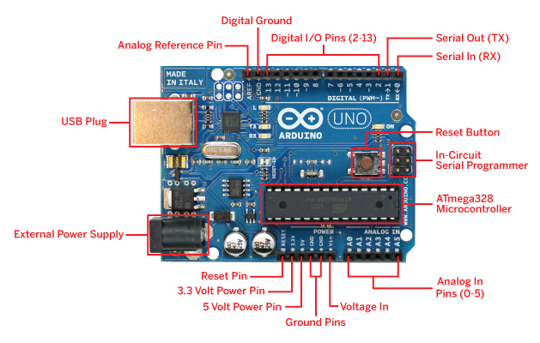Arduino refers to an open source electronics platform or a board and a software program use the board. Arduino/Genuino Uno is a microcontroller board based on the ATmega328P (datasheet). It has 14 digital input/output pins (of which 6 can be used as PWM outputs), 6 analog inputs, a 16 MHz quartz crystal, a USB connection, a power jack, an ICSP header and a reset button. It contains everything needed to support the microcontroller; simply connect it to a computer. With a USB cable or power it with a AC-to-DC adapter or battery to get started. This board forms the main processing unit of the proposed system.

Fig 3.1 Basic Arduino board

**3.1.2 MQ-9 GAS SENSOR**

Sensitive material of MQ-9 gas sensor is SnO2, which with lower conductivity in clean air. It make detection by method of cycle high and low temperature, and detect CO when low temperature (heated by 1.5V). The sensor’s conductivity is more higher along with the gas concentration rising. When high temperature (heated by 5.0V), it detects Methane, Propane etc combustible gas and cleans the other gases adsorbed under low temperature. Please use simple electro circuit, Convert change of conductivity to correspond output signal of gas concentration. MQ-9 gas sensor has high sensitity to Carbon Monoxide, Methane and LPG. The sensor could be used to detect different gases contains CO and combustible gases, it is with low cost and suitable for different application.

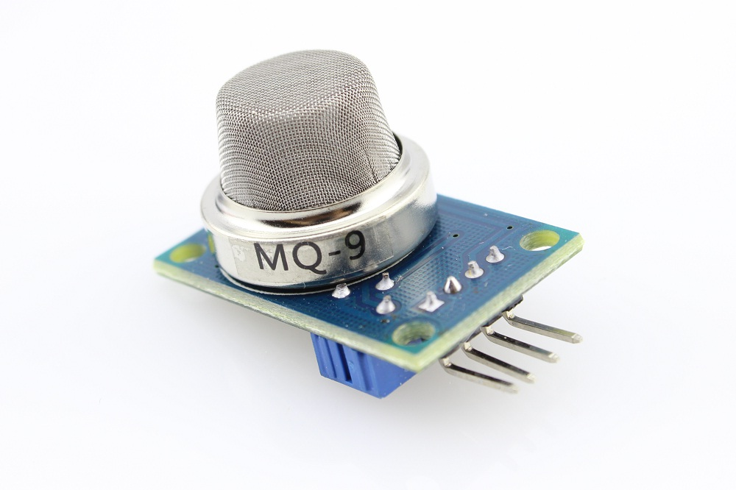

Fig 3.2 MQ-9 Gas Sensor

**3.1.3 MQ-135 GAS SENSOR**

Sensitive material of MQ135 gas sensor is SnO2, which with lower conductivity in clean air. When the target combustible gas exist, The sensor’s conductivity is more higher along with the gas concentration rising. Please use simple electrocircuit, Convert change of conductivity to correspond output signal of gas concentration. MQ135 gas sensor has high sensitity to Ammonia, Sulfide and Benze steam, also sensitive to smoke and other harmful gases. It is with low cost and suitable for different application.

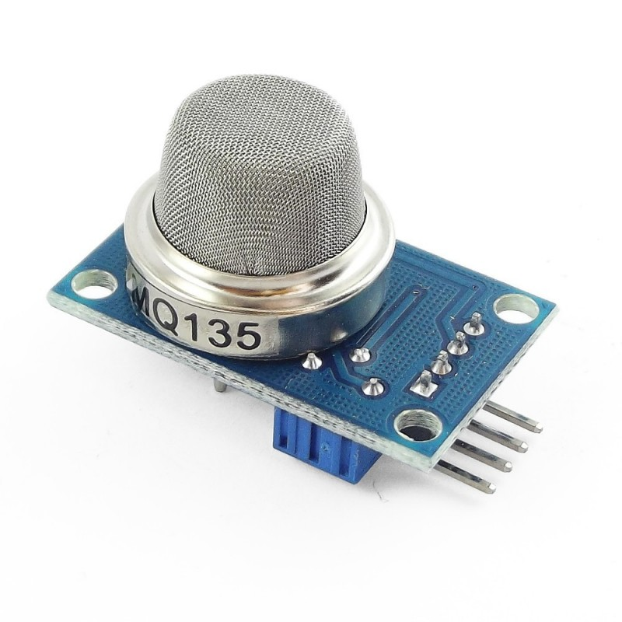

Fig 3.3 MQ-135 Gas Sensor

**3.1.4 DUST SENSOR**

Sharp's GP2Y1010AU0F is an optical air quality sensor, designed to sense dust particles. An infrared emitting diode and a phototransistor are diagonally arranged into this device, to allow it to detect the reflected light of dust in air. It is especially effective in detecting very fine particles like cigarette smoke, and is commonly used in air purifier systems. The sensor has a very low current consumption (20mA max, 11mA typical), and can be powered with up to 7VDC. The output of the sensor is an analog voltage proportional to the measured dust density, with a sensitivity of 0.5V/0.1mg/m3. This sensor is packaged with a 6-pin wires with JST connector to help connect it with your system.

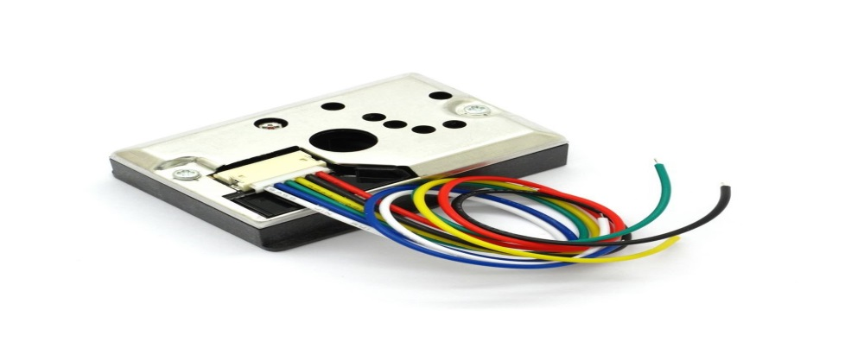

Fig 3.4 Dust Sensor

**3.1.5 GSM/GPRS MODULE**

Global System for Mobile communication (GSM) is an architecture used for mobile communication in most of the countries. The Arduino GSM shield is a GSM modem. GSM MODEM is a class of wireless MODEM devices that are designed for communication of a computer with the GSM network. The MODEM needs AT commands, for interacting with processor or controller, which are communicated through serial communication. These commands are sent by the controller/processor. The MODEM sends back a result after it receives a command. Different AT commands supported by the MODEM can be sent by the processor/controller/computer to interact with the GSM and GPRS cellular network.

GSM is an international standard for mobile telephones. It is an acronym that stands for Global System for Mobile Communications. It is also sometimes referred to as 2G, as it is a second-generation cellular network. It requires a SIM (Subscriber Identity Module) card just like mobile phones to activate communication with the network. Also they have IMEI (International Mobile Equipment Identity) number similar to mobile phones for their identification. A GSM/GPRS MODEM can perform the following operations:

1. Receive, send or delete SMS messages in a SIM.

2. Read, add, search phonebook entries of the SIM.

3. Make, Receive, or reject a voice call.

From the mobile operator perspective, the Arduino GSM shield looks just like a mobile phone. From the Arduino perspective, the Arduino GSM shield looks just like a modem.

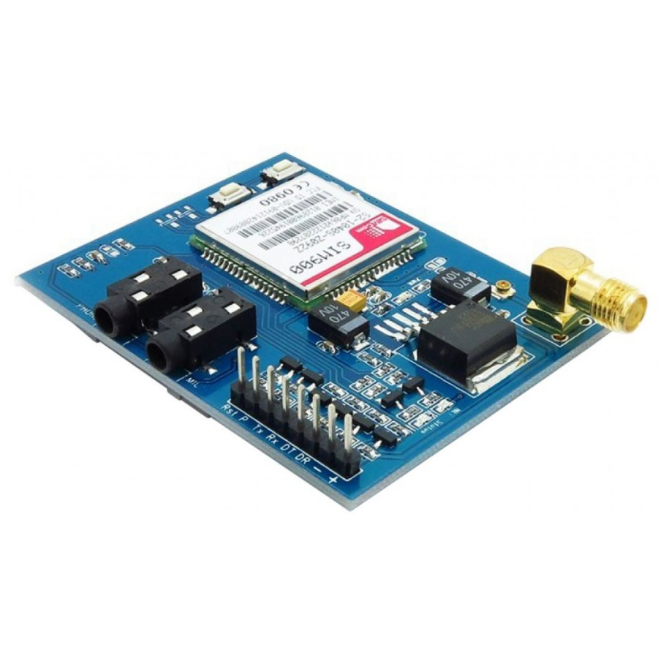

Fig 3.5 GSM/GPRS Module

**3.1.6 SIM**

In addition to the GSM shield and an Arduino, a SIM card is needed. The SIM represents a contract with a communications provider.A SIM card, also known as a subscriber identity module, is a smart card that stores data for GSM cellular telephone subscribers. Such data includes user identity, location and phone number, network authorization data, personal security keys, contact lists and stored text messages. Security features include authentication and encryption to protect data and prevent eavesdropping.The GSM shield accepts cards in the mini-SIM format (25mm long and 15mm wide). And so such SIM is used for accessing the network using prepaid network providers.

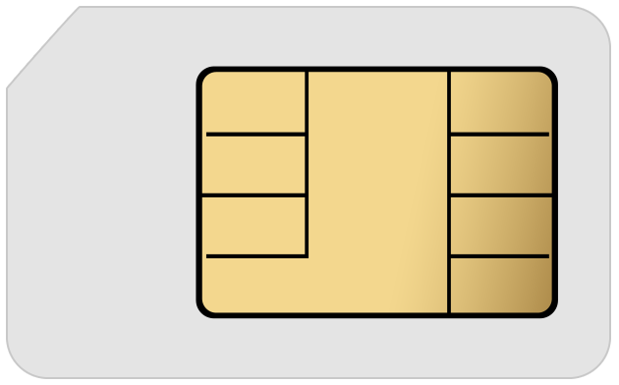

Fig 3.6 SIM Card

**3.2 SOFTWARE REQUIREMENTS**

**3.2.1 Arduino IDE**

The Arduino project involves the usage of Arduino integrated development environment IDE which is a cross-platform application which is developed using java. It originated from the IDE for the languages Processing and Wiring. A program written with the IDE for Arduino is called a sketch. Sketches are saved on the development computer as text files with the file extension .ino. Arduino Software (IDE) pre-1.0 saved sketches with the extension .pde. The Arduino IDE supports the languages C and C++ using special rules of code structuring. The Arduino IDE supplies a software library from the Wiring project, which provides many common input and output procedures. User-written code only requires two basic functions, for starting the sketch and the main program loop, that are compiled and linked with a program stub main() into an executable cyclic executive program with the GNU toolchain, also included with the IDE distribution. The Arduino IDE employs the program avrdude to convert the executable code into a text file in hexadecimal encoding that is loaded into the Arduino board by a loader program in the board's firmware.

**3.2.2 NetBeans IDE**

NetBeans is an integrated development environment (IDE) for Java. NetBeans allows applications to be developed from a set of modular software components called modules. NetBeans runs on Microsoft Windows, macOS, Linux and Solaris. In addition to Java development, it has extensions for other languages like PHP, C, C++ and HTML5.,Javadoc and Javascript. Applications based on NetBeans, including the NetBeans IDE, can be extended by third party developers.The NetBeans Team actively supports the product and seeks feature suggestions from the wider community. Every release is preceded by a time for Community testing and feedback

**3.2.3 Apache Tomcat server**

Apache Tomcat, often referred to as Tomcat Server, is an open-source Java Servlet Container developed by the Apache Software Foundation (ASF). Tomcat implements several Java EE specifications including Java Servlet, JavaServer Pages (JSP), Java EL, and WebSocket, and provides a "pure Java" HTTP web server environment in which Java code can run.Tomcat is developed and maintained by an open community of developers under the auspices of the Apache Software Foundation, released under the Apache License 2.0 license, and is open-source software.

**3.2.4 XAMPP**

XAMPP is a free and open source cross-platform web server solution stack package developed by Apache Friends,consisting mainly of the Apache HTTP Server, MariaDB database, and interpreters for scripts written in the PHP and Perl programming languages.XAMPP stands for Cross-Platform (X), Apache (A), MariaDB (M), PHP (P) and Perl (P). It is a simple, lightweight Apache distribution that makes it extremely easy for developers to create a local web server for testing and deployment purposes. Everything needed to set up a web server – server application (Apache), database (MariaDB), and scripting language (PHP) – is included in an extractable file. XAMPP is also cross-platform, which means it works equally well on Linux, Mac and Windows. Since most actual web server deployments use the same components as XAMPP, it makes transitioning from a local test server to a live server extremely easy as well.

**3.2.5 Python**

Python is an [open source](https://simple.wikipedia.org/wiki/Open_source) [programming language](https://simple.wikipedia.org/wiki/Programming_language). Python is an interpreted language. Interpreted languages do not need to be [compiled](https://simple.wikipedia.org/wiki/Compiled_language) to run. A program called an [interpreter](https://simple.wikipedia.org/wiki/Interpreter_(computing)) runs Python code on almost any kind of computer. This means that a programmer can change the code and quickly see the results. This also means Python is slower than a compiled language like [C](https://simple.wikipedia.org/wiki/C_(programming_language)), because it is not running [machine code](https://simple.wikipedia.org/wiki/Machine_code) directly.Python is a good programming language for beginners. It is a high-level language, which means a programmer can focus on what to do instead of how to do it. Writing programs in Python takes less time than in some other languages.Python drew inspiration from other programming languages like C, [C++](https://simple.wikipedia.org/wiki/C%2B%2B), [Java](https://simple.wikipedia.org/wiki/Java_(programming_language)), [Perl](https://simple.wikipedia.org/wiki/Perl), and [Lisp](https://simple.wikipedia.org/wiki/LISP" \o "LISP).Python has a very easy-to-read syntax. Some of Python's syntax comes from C, because that is the language that Python was written in.

**CHAPTER 4**

**SYSTEM DESIGN**

**4.1 SYSTEM ARCHITECTURE**

The project has come up with the following proposed architecture for the implementation of PAVAN- AIR POLLUTION MONITORING AND ALERT SYSTEM.

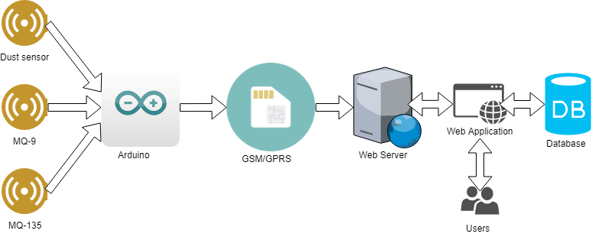

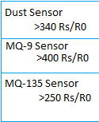

Fig 4.1 System Architecture

The system is monitored through the web application as a whole. The data’s from the three sensors are collected at regular interval of time and processed in Arduino and converted into their units and sent to the database through GSM/GPRS module for storing which can be helpful for generate reports and statistics. The stored data can be accessed anytime from the database through web application and the report can be generated. The live data can be simultaneously stored in the database and can be viewed through the web application.

**4.2 DATA FLOW DIAGRAM**

The first step involved is sensing the environment through sensors. All the data’s which recorded by the sensors at regular intervals are Raw data and those Raw data’s have to be converted into their respective units. The data recorded by Dust sensor is converted into micro-grams/cubic meter and the data recorded by MQ-9 and MQ-135 are converted into ppm.

This is followed by the second process to send the converted data’s to database through webserver using GSM/GPRS Module for storing them. The data’s stored in the database can be retrieved anytime through web application for the report generation and statistics as per the conditions/range set by the user.

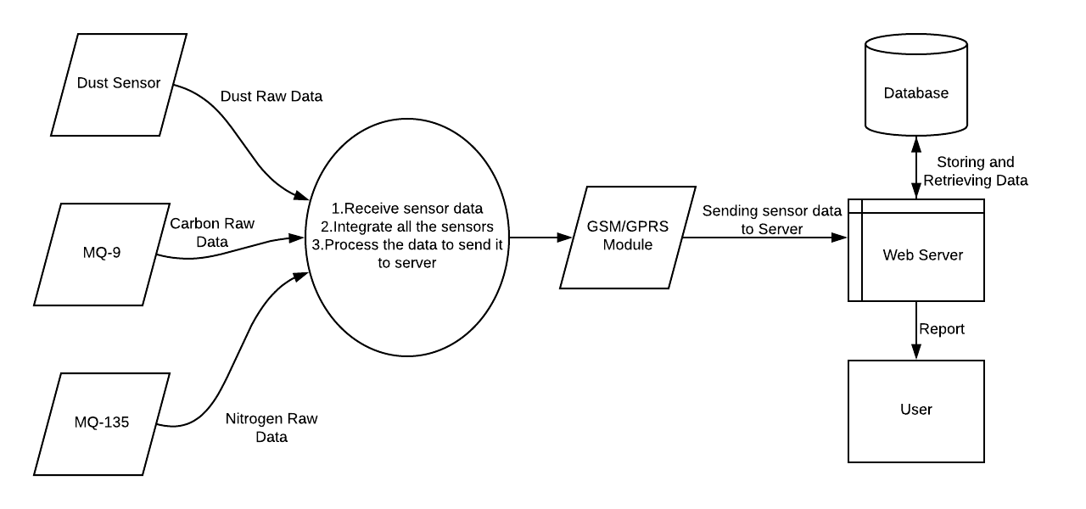

Fig 4.2 Data Flow Diagram

**4.3 MODULE DESCRIPTION**

The process of Air Pollution Monitoring and Alert System is done through various modules. Such modules involved in this system are as follows:

* + - * Sensing the Environment (Sensors)
      * Processing the sensor data (Arduino)
      * Correlating the source of pollutants(GSM/GPRS Module)
      * Storing the pollutant data(Web Server)

**4.3.1 Sensing the Environment(Sensors):**

The sensing of environment is done by the sensors namely Dust,MQ-9 and MQ-135 which used to sense the pollutants such as dust, carbon and its constituents and nitrogen and its constituents respectively. Sensing is done at a regular interval of time and those sensed data’s are sent to the Arduinosimultaneously for processing. The data’s recorded by the sensors are raw data which have to be processed.

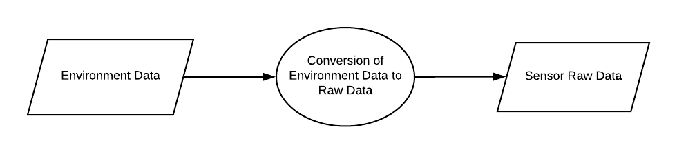

Fig 4.3 Module Sensors

.

* + 1. **Processing the Sensor Data(Arduino):**

The raw data from the sensors are processed in the Arduino. Processing done here is converting the raw data’s into their respective units. The data recorded by Dust sensor is converted into micro-grams/cubic meter and the data recorded by MQ-9 and MQ-135 are converted into ppm. The processed data have to be stored.

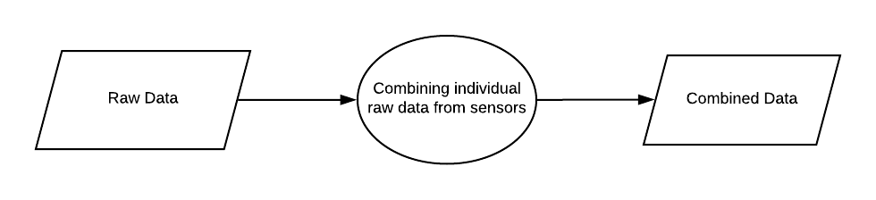

Fig 4.4 Module Arduino

* + 1. **Correlating the source of pollutants(GSM/GPRS Module):**

The processed data have to be stored in the database. So the data have to be travelled from the Arduino to the database. For that, a GSM/GPRS Module is used for the transportation of data. The processed data is sent to the GSM/GPRS Module and the module send the data to the database.

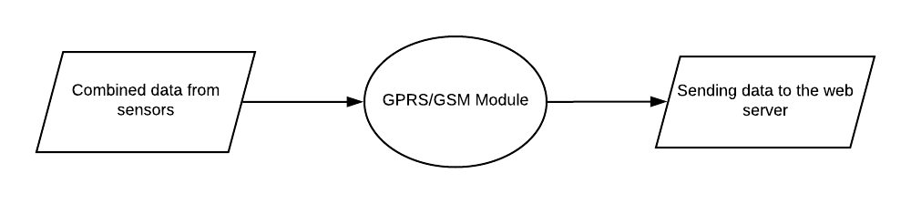Fig 4.5 Module GSM/GPRS

* + 1. **Storing the pollutant data(Web-Server):**

The data from the GSM/GPRS Module is stored in the database for the future use. The stored data can be used for report generation and statistics. The data can be retrieved anytime from the database through web application.

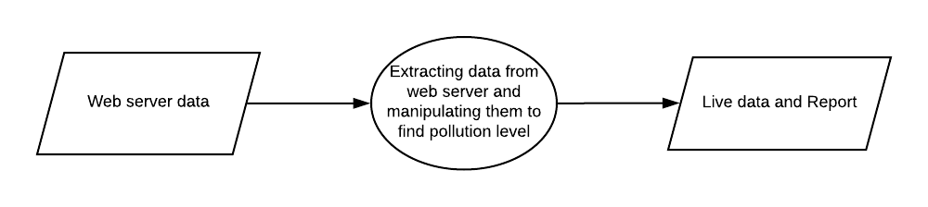Fig 4.6 Module Web-Server

**CHAPTER 5**

**EXPERIMENTAL RESULTS**

**5.1 IMPLEMENTATION RESULTS**

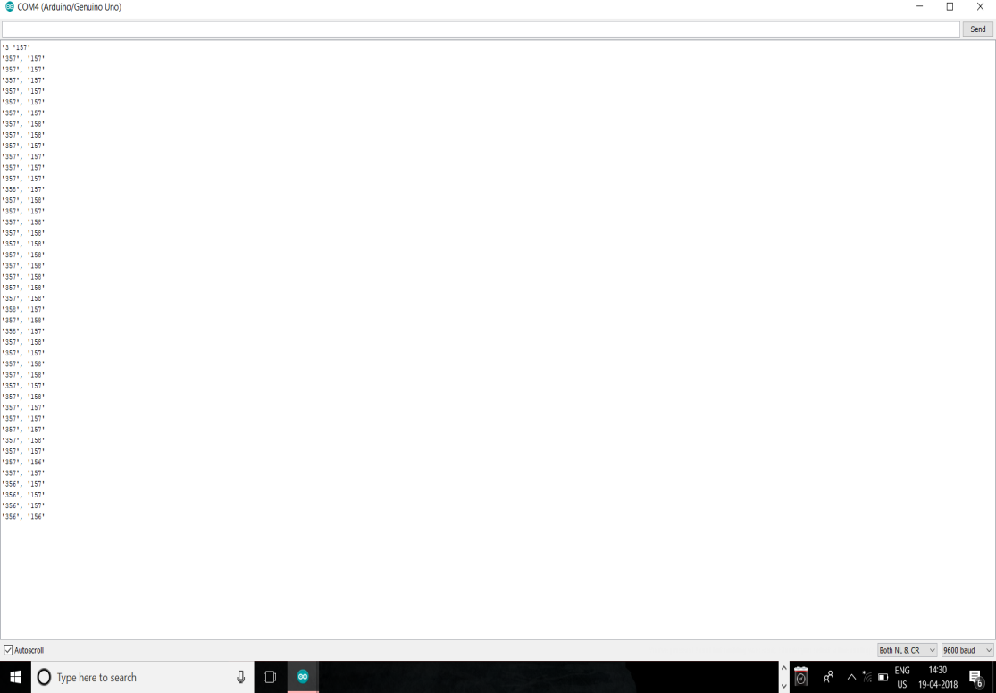

Fig 5.1 Serial Monitor

**,**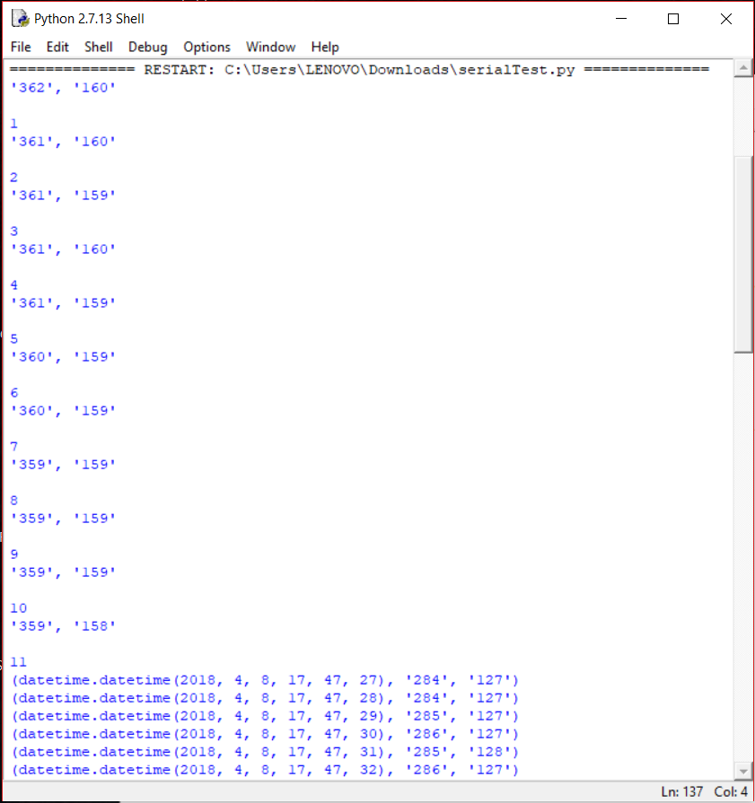

Fig 5.2 Python shell

Fig 5.1 refers to the serial monitor of the Arduino IDE where the data’s from the sensors are displayed continuously. Fig 5.2 refers to the Python shell where the fixed counts of data from the sensors are stored in the database along with the time of the each recording.

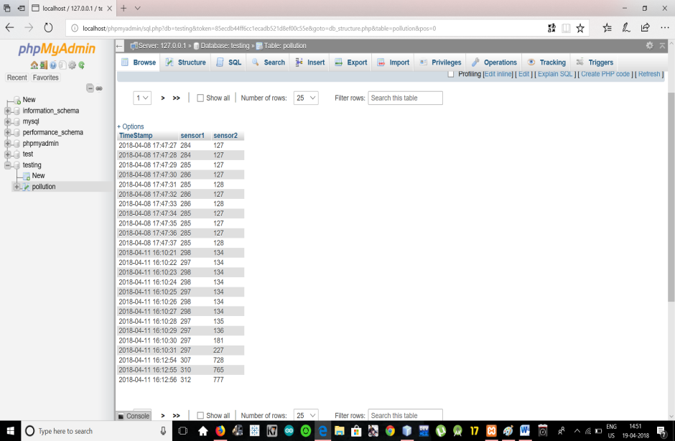

Fig 5.3 Database

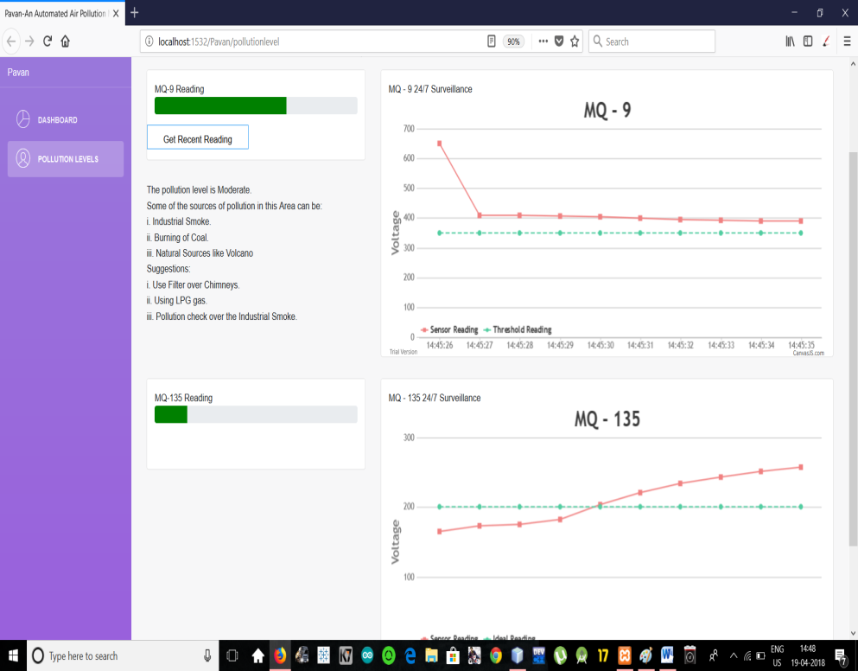

Fig 5.4 Front End

Fig 5.3 shows how the data’s are stored in the database along with the respective time stamps. Fig 5.4 shows how the front end looks. Based on the sensor readings stored in the database the graph in the front end shows the level of pollution for easy understanding of the user.

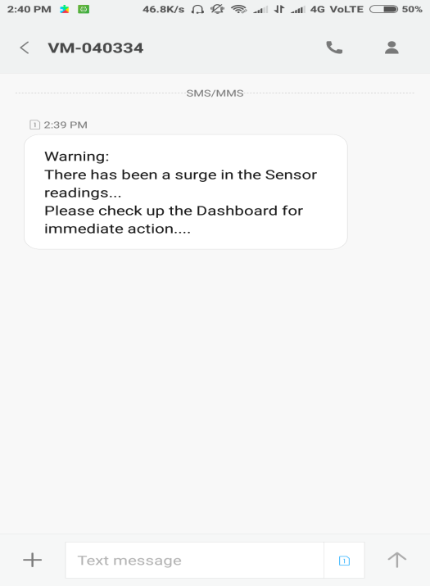

Fig 5.5 Warning Message

Fig 5.5 shows the warning message sent from the system when there is a surge in the level of pollution.

**5.2 PERFORMANCE ANLYSIS**

This project determines four types of pollutants and their sources based on the sensor readings. They are

* Pollution caused by mobile sources(vehicles)
* Pollution caused by stationary sources(factories)
* Pollution caused by area sources(agriculture, wood burning)
* Pollution caused by natural sources(wind, hash dust, volcano)

As per the datasheets information, MQ 9 is responsible for sensing carbon monoxide and its oxides. MQ 135 is responsible for sensing nitrogen and its oxides. If there is a surge in MQ 9 and no changes in MQ 135 means, the pollutant sources will be mobile sources and area sources. If there is a surge in MQ 135 and no changes in MQ 9 means, the pollutant sources will be stationary sources and natural sources. If there is a surge in both the sensors then all the four types of pollutants will be the source. Based on the sensor readings and the type of source, the suggestion to overcome the situation also displayed in the dashboard along with the readings.

**CHAPTER 6**

**TESTING**

**6.1 TEST PLAN**

System testing is the process of validating and verifying that a system

* meets requirements that guided its design and development
* works as expected
* Can be implemented with the same characteristics.

So, testing has been carried out to check whether the proposed system has met the requirements and has derived the expected result.

**6.2 TEST DESIGN**

System testing is a process of checking whether the developed application is working according to the original objectives and requirements. The system should be tested experimentally with test data so as to ensure that the system works according to the required specification. When the system is found working, test it with actual data and check performance.

All tests should be traceable to customer requirements. The focus of testing will shift progressively from programs. Exhaustive testing is not possible. To be more effective, testing should be one, which has probability of finding errors.

The following are the attributes of good test

* A good test has a high probability of finding an error.
* A good test is not redundant.
* A good test should be “Best of Breed”.
* A good test should neither too simple nor too complex.

**6.2.1 TYPES OF TESTING**

The details of the software functionality tests are given below. The testing procedure that has been used is as follows:

* + Unit Testing
  + Component & System Testing

**6.3 TEST EXECUTION**

**6.3.1 UNIT TESTING**

|  |  |  |  |
| --- | --- | --- | --- |
| **Project Name:** | Pavan- An Air Pollution Monitoring and Alert System. | **Test Designed by:** | Agilan S  Hindu Sreeni |
| **Module Name:** | Unit testing | **Test Designed date:** | 15/02/2018 |
| **Pre-condition:** | Setup of the components along with the power source and program | **Test Executed by:** | Harish Raj  Karthik U  FaheenFathima B N |
| **Description:** | Checking every component of the project for its functionality | **Test Execution date:** | 27/02/2018 |

|  |  |  |  |  |  |  |  |
| --- | --- | --- | --- | --- | --- | --- | --- |
| **Test Case#** | **Test Title** | **Test Steps** | **Test Data** | **Expected Result** | **Actual Result** | **Status**  **(Pass/Fail)** | **Post Condition** |
| M1_1 | MQ 9 sensor test | Preheat the sensor  Connect the sensor with arduino along with the code | LPG and exposing sensors to normal environment. | Completely functional and adaptable sensor | Detected the pollutants in air.  Provided actual change in the reading | **pass** | **-** |
| M1_2 | MQ 135 sensor test | Preheat the sensor  Connect the sensor with arduino along with the code | LPG and exposing sensors to normal environment. | Completely functional and adaptable sensor | Detected the pollutants in air.  Provided actual change in the reading | **pass** | **-** |
| M1_3 | Dust sensor | Connect the sensor with Arduinowith resisters and potentiometer | Exposing sensor in normal condition then add some dust into the sensor to check the ppm of dust | Provide the dust data with particle size | Did not detect the dust.  The sensor value always turned to be zero | **fail** | Unreliable and so could not be used in the project |
| M1_4 | GSM/GPRS MODULE | Assembling with a SIM card and Arduinouno | Check if we can send a text message to a phone using the arduino code | Send SMS to the corresponding mobile number | The SMS was not sent due to improper voltage supply to the module | **fail** | Could not be used in the project. An alternate approach was used |
| M1_5 | Arduinouno board | Use a simple Arduino with LED to test the working | The arduino code with time delays to check the working of LED | Simply blink the LED and post the results in seriel monitor | The Arduino board worked perfectly with multiple test cases | **pass** | Used as the prime microcontroller in the project. |

Table 6.1 Unit Testing

**6.3.2 COMPONENT & SYSTEM TESTING**

|  |  |  |  |
| --- | --- | --- | --- |
| **Project Name:** | Pavan- Air Pollution Monitoring and Alert System. | **Test Designed by:** | FaheenFathima B N |
| **Module Name:** | Processing the sensor data | **Test Designed date:** | 02/03/2018 |
| **Pre-condition:** | Availablity of sensors and the microcontroller | **Test Executed by:** | Hindu Sreeni  Agilan S |
| **Description:** | To test if sensors are compatible with each other and if they can work together with the processor | **Test Execution date:** | 10/03/2018 |

|  |  |  |  |  |  |  |  |
| --- | --- | --- | --- | --- | --- | --- | --- |
| **Test Case#** | **Test Title** | **Test Steps** | **Test Data** | **Expected Result** | **Actual Result** | **Status**  **(Pass/Fail)** | **Post Condition** |
| M2_1 | Compatiblity of MQ-9 and MQ-135 sensor | **1.**set up the MQ-9 and MQ-135 sensor with the Arduino  **2**.develop the Arduino code with both MQ-9 and MQ-135 characteristics  **3.**Check the serial monitor for the readings of the sensors | Voltage and Resistance of the sensors should be the input when exposed to the test environment | Serial monitor must display the minimum value for detection  MQ -9 range (100 to 600) with threshold 350  MQ-135  Range(100 to 600) with threshold 300 | Time variant results varying from 200 to 550 for both the sensors | **Pass** | Send the serial data to the data base using python |

Table 6.2 Processing Sensor Data

|  |  |  |  |
| --- | --- | --- | --- |
| **Project Name:** | Pavan- Air Pollution Monitoring and Alert System. | **Test Designed by:** | Agilan S |
| **Module Name:** | Storing sensor data | **Test Designed date:** | 16/03/2018 |
| **Pre-condition:** | Availablity of sensors data and the database MySQL | **Test Executed by:** | FaheenFathima B N  Hindu Sreeni |
| **Description:** | To test if sensor data is stored in MySQL and if it can be accessed using XAMPP | **Test Execution date:** | 25/03/2018 |

|  |  |  |  |  |  |  |  |
| --- | --- | --- | --- | --- | --- | --- | --- |
| **Test Case#** | **Test Title** | **Test Steps** | **Test Data** | **Expected Result** | **Actual Result** | **Status**  **(Pass/Fail)** | **Post Condition** |
| M2_2 | Store data in the database | 1.Use serial port communication with the Arduino to MySQL database  2.Connect the MySQL with XAMPP to check the data stored in database | Continous processed data from the sensors | A table containing the sensor data visible in XAMPP | Sensor data with time stamp is stored as a table in the database | **Pass** | Use the table in user interface in a sensible manner |

Table 6.3 Storing Sensor Data

|  |  |  |  |
| --- | --- | --- | --- |
| **Project Name:** | Pavan- Air Pollution Monitoring and Alert System. | **Test Designed by:** | Karthik U |
| **Module Name:** | Connecting to the server | **Test Designed date:** | 30/03/2018 |
| **Pre-condition:** | MySQL data and XAMPP along with java servelets | **Test Executed by:** | Karthik U  Harish R |
| **Description:** | To test if the data can be connected to the server | **Test Execution date:** | 03/04/2018 |

|  |  |  |  |  |  |  |  |
| --- | --- | --- | --- | --- | --- | --- | --- |
| **Test Case#** | **Test Title** | **Test Steps** | **Test Data** | **Expected Result** | **Actual Result** | **Status**  **(Pass/Fail)** | **Post Condition** |
| M2_3 | Connect to the server(Apache Tomcat) | 1.Develop servelet code in java to connect with Apache Tomcat | Data from the MySQL database | Establish connection with the server | Connection was established along with the transmission of data | **Pass** | Develop a dynamic front end using the servelet data |

Table 6.4 Connecting to Server

|  |  |  |  |
| --- | --- | --- | --- |
| **Project Name:** | Pavan- Air Pollution Monitoring and Alert System. | **Test Designed by:** | Harish R |
| **Module Name:** | Developing front end | **Test Designed date:** | 05/03/2018 |
| **Pre-condition:** | Server connection and data from the sensors | **Test Executed by:** | Harish R  Karthik U  FaheenFathima B N |
| **Description:** | To test if sensors are compatible with each other and if they can work together with the processor | **Test Execution date:** | 15/04/2018 |

|  |  |  |  |  |  |  |  |
| --- | --- | --- | --- | --- | --- | --- | --- |
| **Test Case#** | **Test Title** | **Test Steps** | **Test Data** | **Expected Result** | **Actual Result** | **Status**  **(Pass/Fail)** | **Post Condition** |
| M2_4 | Develop front end using java servelets and nodejs | 1.Create interactive web page  2.develop progress bar for both the sensors  3.Develop live chart for both the sensors  4.Check the progress bar and chart with multiple test cases from the sensor reading  5.  Provide guiudelines for respective sensor reading  6.Intimate if the pollution level is high using text message | 1.Data from the MySQL database.  2.Guidelines can provided in regarding to the sensors in java frontend code  3.  Warning message to Online text senders can be used for sending alert messages | 1.Dynamic web page interactive with user  2.live chart and progress bar for both the sensors  3.Providing guidelines based on the test cases of pollution monitoring  4.Alerting the official about high pollution using SMS | 1.Dynamically refreshed user friendly front end  2.pollution level is displayed along with the time stamp in a live chart along with a progress bar  3.Conditional guidelines for pollution recovery is displayed in the web page  4.Text message is sent using online text messages | **Pass** | Highly effective live chart with precision and monitoring system to alert people with increasing pollution |

Table 6.5 Developing Front End

**CHAPTER 7**

**CONCLUSION AND FUTURE WORK**

**7.1 CONCLUSION**

Pollution prevails to be a life-threatening problem that the whole world faces and hence it becomes a priority where everyone has to be aware of the growing danger in the locality. Thus PAVAN provides user friendly approach towards the environmental education. It can clearly detect and alert the sudden rise in toxic level of air with proper measures and guidelines. Thus PAVAN proves to be an intelligent approach towards the protection and prevention of air pollution hazards met in the future. PAVAN becomes an integrated system where the measure of pollutant levels can be identified uniquely for each pollutant and can be improved over the effects of toxicity in air and the vulnerability of the locality to pollution.

**7.2 FUTURE WORK**

There is some future work which can be done in this report. They are

* Applying machine learning algorithms to the applied statistics to estimate and foresee the toxic level in air.
* Developing a mobile application with the web page to provide instant access to the pollution data level.
* After several years of implementation when the data acquired is manifold, data analysis can be used to handle the mass data.

**REFERENCES**

1. Chen Xiaojun1, Liu Xianpeng2, Xu Peng3: IOT- Based Air Pollution Monitoring and Forecasting System, International Conference on Computer and Computational Sciences (ICCCS) 2015
2. ShwetalRaipure. Deepak Mehetre: Wireless Sensor Network Based PollutionMonitoring System in Metropolitan Cities, IEEE ICCSP conference,2015.
3. Siva Shankar Chandrasekaran, Sudharshan Muthukumar and Sabeshkumar Rajendran: Automated Control System for Air Pollution Detection in Vehicles, 4th International Conference on Intelligent Systems, Modelling and Simulation,2013
4. Souhir BEDOUI, Sami GOMRI and Hekmet SAMET: Air Pollution Monitoring System using LabVIEW, 12th International Multi-Conference on Systems, Signals & Devices, 2015
5. Suganya E, Vijayashaarathi S: Smart Vehicle Monitoring System for Air Pollution Detection using Wsn, International Conference on Communication and Signal Processing, 2016.
6. Yangyang Ma, Shengqi Yang, Zhangqin Huang, YibinHou, Leqiang Cui, and Dongfang Yang: Hierarchical Air Quality Monitoring System Design, International Symposium on Integrated Circuits (ISIC), 2014
7. Software Engineering: A Practitioner’s Approach by Pressman.
8. https://circuitdigest.com/microcontroller-projects/iot-air- pollution-monitoring-using-arduino
9. https://nevonprojects.com/iot-air-sound-pollution-monitoring- system/
10. https://www.aeroqual.com/outdoor-air-quality
11. https://plot.ly/arduino/air-quality-tutorial/
12. http://www.instructables.com/id/Air-Pollution-Detector/
13. https://www.google.co.in/amp/indianexpress.com/article/
14. <https://www.google.co.in/amp/thehindu.com/article/>